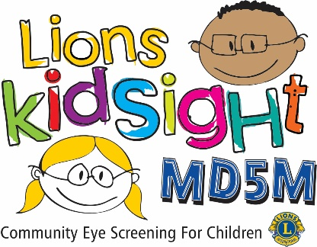
MD5M Lions KidSight
Results of Vision Screening
Dear Parent,
Your child ____________________________________ was screened for possible vision problems by trained volunteers from the <<< --- Click to enter Club Name --- >>> Lions Club.
No serious vision problems were detected, but it is important to realize this screening does not replace the need for a professional eye examination.
Lions Clubs and other organizations such as the American Academy of Pediatrics recommend vision screenings and professional eye examinations as part of regular health examinations for children.
If the box “Unable To Screen” is checked, this means that our instrument was unable to obtain a valid result. If you suspect your child has a vision issue, we recommend a professional examination with your eye care provider.
If you have any questions about this screening, please feel free to contact <<< --- Click to enter Name & Contact Info for your District Chair --- >>>
Sincerely,
<<< --- Click here to enter your name --- >>>
☐ Unable To Screen.

NOT REFERRED

