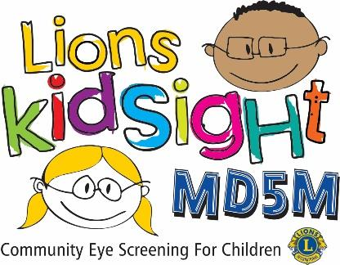

Dear << -- Name of Preschool -- >> Parent/Guardian.

We are pleased to tell you that the << -- Enter Lions Club Name -- >> will be providing a free vision screening << -- For who and when -- >>. Members of the Lions clubs have been certified in the use of a vision screener. The device they use is similar to the ones used in an eyecare professionals’ office. The individual screening of children only takes a few seconds and is performed from a distance of about three feet. There is no physical contact with the child and no eye drops are administered.

According to educational experts, eighty percent of learning is visual. On average, 2 to 3 children in a classroom of 20 children may have an eye condition that could be affecting their learning. One possible condition is called ‘lazy eye’ and if left untreated may cause permanent eye damage.

The vision screener we use is capable of screening for near-sightedness, far-sightedness, astigmatism and pupil size deviations. In addition, it will detect unequal refractive power and eye misalignment which can result in amblyopia, commonly known as “lazy eye.” It is important to understand that this is only a screening and does not replace an examination or diagnosis of vision problems.

A print-out of the results will be provided for each child who should receive follow-up care from an eye care professional. These results will be shared with you by the facility staff. If no visual condition is detected, no follow-up information will be sent home. If you do NOT want your child to participate in the screening (or opt out), please notify << -- Desired school contact -- >>.

Again, this service is offered free of charge under the MD5M Lions KidSight Foundation’s vision screening program. If you have technical questions about the screening, please contact << -- Name and email address of district KidSight Director -- >>.

Sincerely,

<< -- Who is sending this letter -- >>

