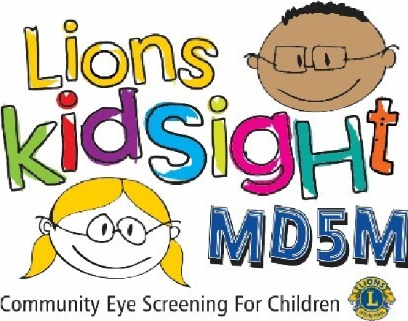
MD5M Lions KidSight Foundation, Inc
Sight Saver Partner Award Application
Partner Awardee Name ___________________________________________________
IMPORTANT! Please print name clearly and exactly as it should appear on plaque.
Nominator: ________________________________________District: ________________
Please print the name, complete address, phone number and email address of the person to whom the plaque is to be sent for presentation to the recipient.
Note! The plaques are sent via UPS and cannot be delivered to a PO Box

Name___________________________________________________________________
Street Address____________________________________________________________
City, State or Province, Postal Code ___________________________________________
Email Address_____________________________________Phone___________________
E-Mail completed form to: KidsightMD5M.treasurer@gmail.com
MD5M Lions KidSight program is designed to provide free vision screening to children with the goal of detecting common eye disorders especially those that could lead to Amblyopia or commonly called “lazy eye”
The ability to see clearly can impact many aspects of a child’s development. Success in school and athletics, as well as social interaction.
The MD5M Lions KidSight “Sight Saver Partner” award is an excellent way to honor organizations or individuals who have distinguished themselves on behalf of children’s vision, and who see and care for the needs of those less fortunate than themselves.
The award recipient receives a beautiful plaque.
- Allow 4 weeks for plaque delivery.
Criteria:
An organization or individual that has gone above and beyond to promote and assist with Lions MD5M KidSight vision screening.

