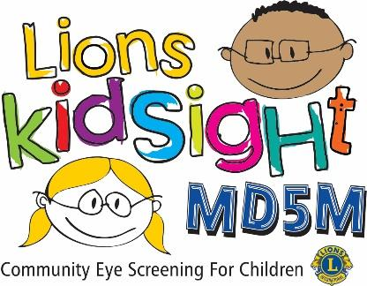

Dear <<< --- Name of Preschool --- >>> parent/guardian.

According to educational experts, eighty percent of learning is visual. On average, 2 to 3 children in a classroom of 20 children may have an eye condition that may be affecting their learning. One possible cause is called ‘lazy eye’ and left untreated; this condition may cause permanent eye damage.

I am pleased to tell you that the <<< --- Click to enter Lions Club Name --- >>> will be providing a free vision screening on <<< --- Click here to enter Screening Date --- >>>.

Members of the Lions clubs have been certified in use of a vision screener. The device they use is similar to the ones used in an eyecare professionals’ office. The individual screening of children takes just a few seconds and is performed from a distance of about three feet. There is no physical contact with the child and no eye drops are administered.
To have your child participate in the screening you will need to fill out and sign the Parental Consent Form included with this letter and send or bring it to our office before the date of the screening.

The vision screener we use is capable of screening for near-sightedness, far-sightedness, astigmatism and pupil size deviations. In addition, it will detect unequal refractive power and eye misalignment which can result in amblyopia, commonly known as “lazy eye.” It is important to understand that this is only a screening and does not constitute an examination or diagnosis of vision problems.

Again, this service is offered free of charge under the MD5M Lions KidSight Foundation’s vision screening program. If you have technical questions about the screening, please contact <<< Name and Phone of local Lion Club Contact >>>.

Sincerely yours,

<<< Name of the Preschool Director >>>

